**GIT**

**GIT-HOL**

**Hands On – 3**

**Steps:**

Create a new branch and List branch

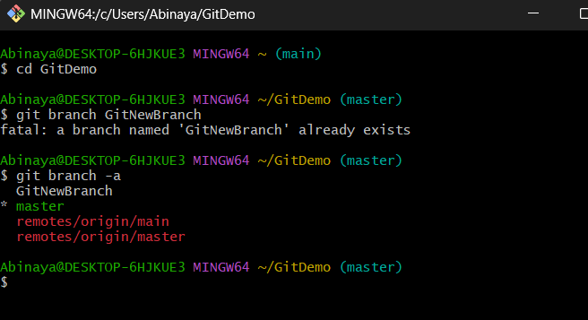

Switch branch

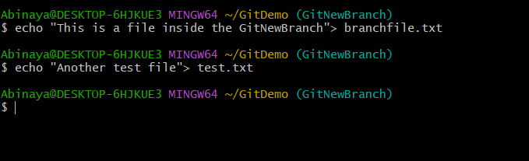

Add files

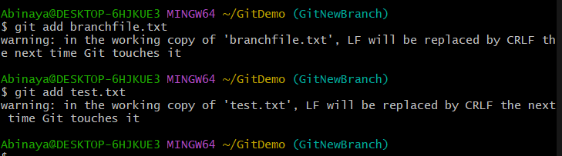

5. Commit changes

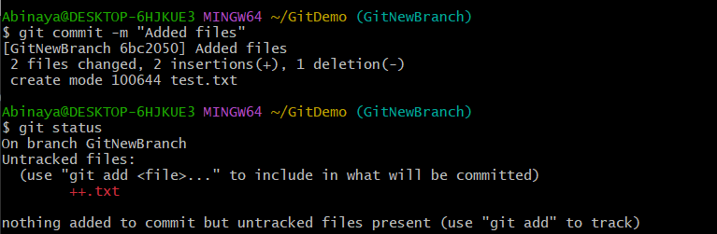

**Merging**

1.Switch to master

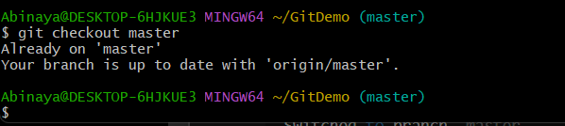

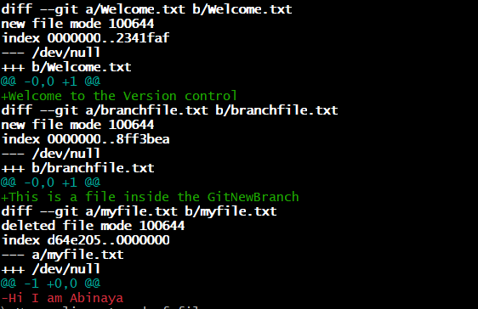2.Show branch differences

3.Merge branch into master  
  
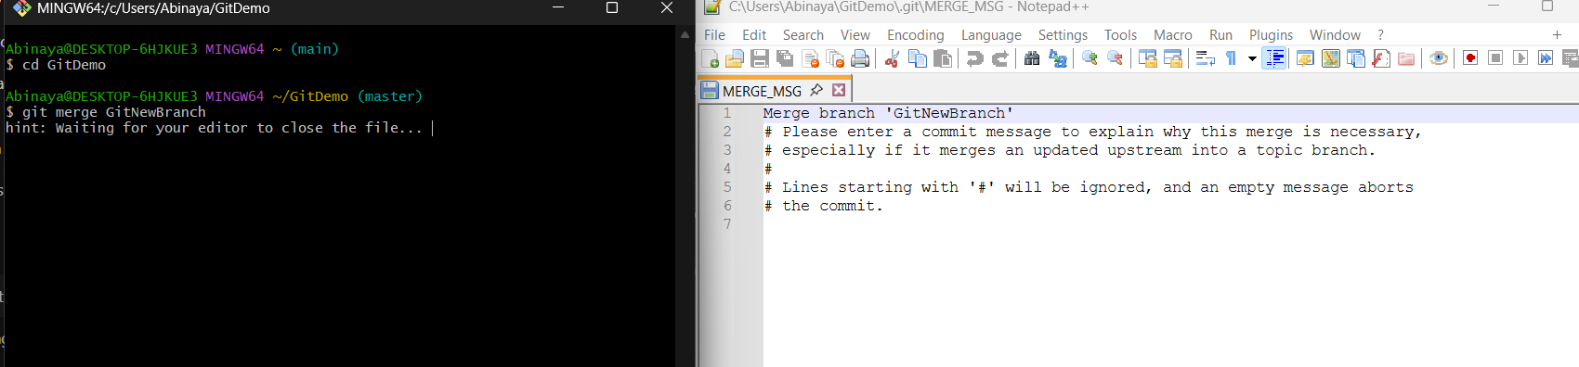

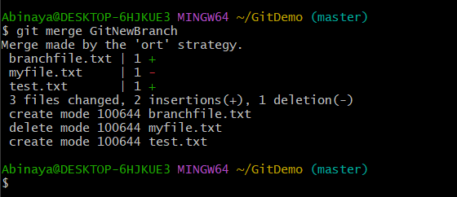

4.View merge history

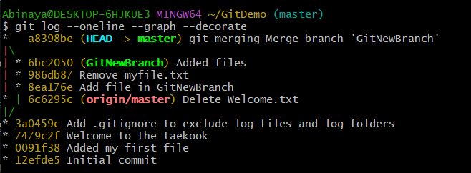

5.Delete merged branch



6.Final status check

